|  |  |  |  |  |
| --- | --- | --- | --- | --- |
|  |  |  | 3 MARCH 2022 | |
| NUMERICAL COMPUTING (CS325) | | | | |
|  | | | | |
| Course Instructor:  Sir Jamil Usmani | |  |  |  |

**NUMERICAL COMPUTING (CS325)**

**PROJECT**

**LAB – 1**

**Group Members:**

* Mohammad Basil Ali Khan (20K-0477)
* Ali Jodat (20K-)
* Abdul Ahad Shaikh (20K-)
* Mohammad Umer (20K-)

**Project Title:**

**LAB 1: Solution of Non Linear Equation in one Variable f(x) = 0**

**Aim:**

To understand the fundamental concepts of scientific programming using python.

**Description:**

We selected three methods of Lab1.

1. Bisection Method
2. Regular Falsi Method
3. Secant Method

First we have studied the algorithm of then we have written the programming of that method.

**IDE and Programming Language:**

We have chosen python programming language and IDE we are using is Visual Studio Code.

**Library Used:**

We have imported 3 libraries:

1. sympy library for to get equation solution on particular intervals and can initialize symbols.
2. tabulate library to generated table on each iteration.
3. array library to save each iteration values to use in next iteration.

**Implementation and Code Snippets:**

* **Bisection Method:**

**Formula:**

$$c=\frac{a+b}{2} ;where a and b are intervals [a, b]$$

**Algorithm:**

Step 1: Find two points, say a and b such that a < b and f(a)* f(b) < 0

Step 2: Find the midpoint of a and b, say “c”

Step 3: c is the root of the given function if f(c) = 0; else follow the next step

Step 4: Divide the interval [a, b] – If f(c)*f(a) <0, there exist a root between t and a  
 else if f(c) *f (b) < 0, there exist a root between t and b

Step 5: Repeat above three steps until f(c) = 0.

**Code Snippets:**

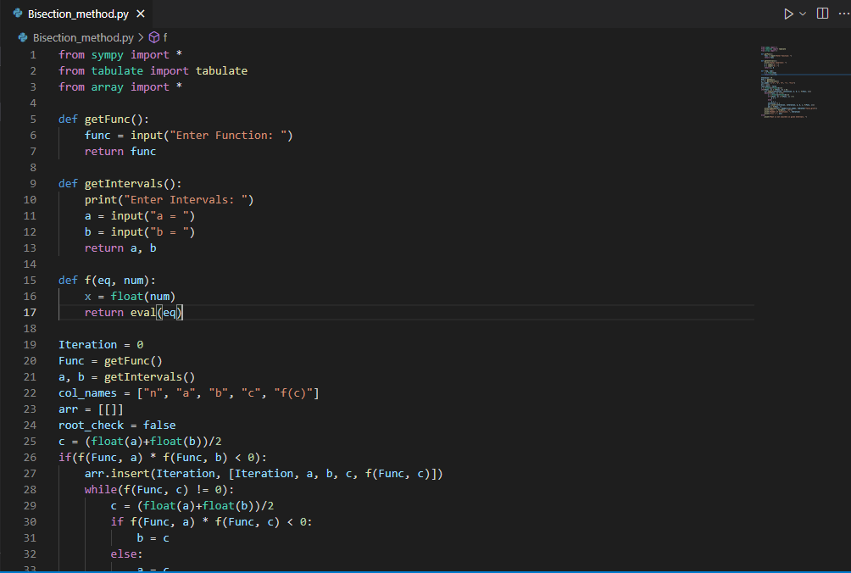

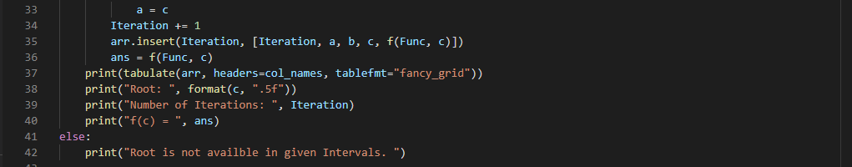

**Output:**

Input: $x^{3}+4x^{2}-10= 0 ;[1, 2]$

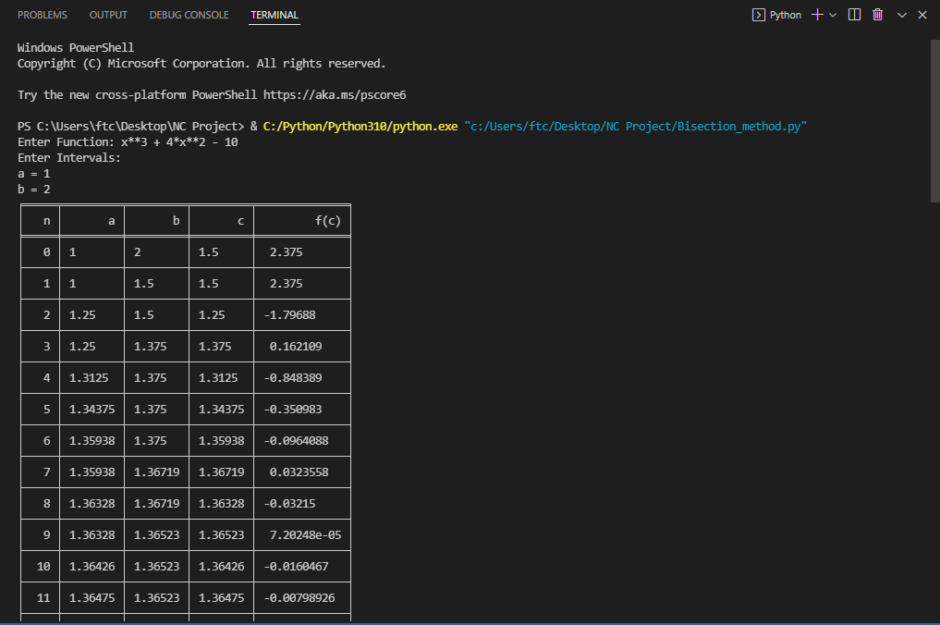

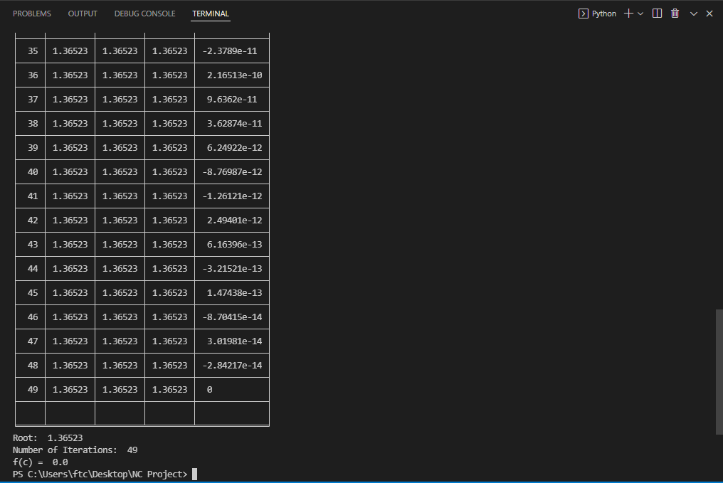

* **Secant Method:**

**Formula:**

$$\frac{A(f\left(b\right))-B(f\left(A\right))}{f\left(B\right)-f(A)} ;where A and B are intervals [A, B]$$

**Algorithm:**

Given an equation f(c) = 0   
Let the initial guesses be a and b  
Do

$$c= \frac{a(f\left(b\right))-b(f\left(a\right))}{f\left(b\right)-f(a)}$$

while (f(c) not equals 0)

**Code Snippets:**

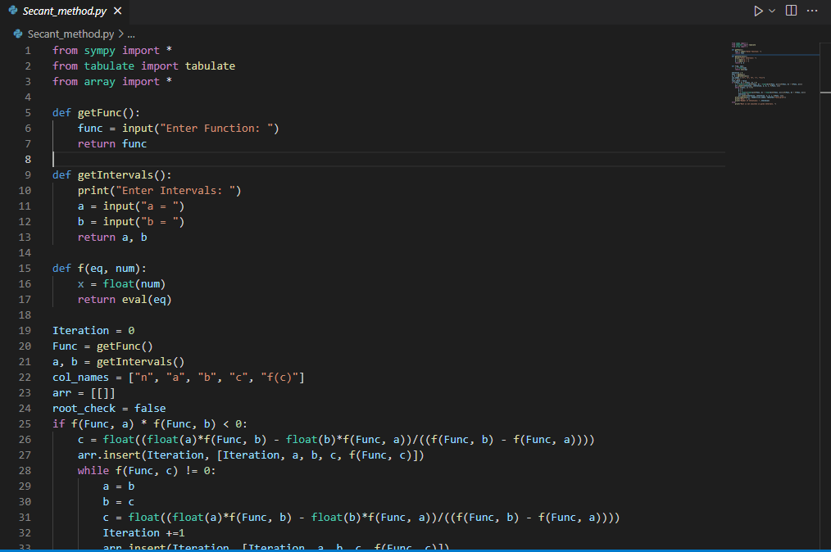

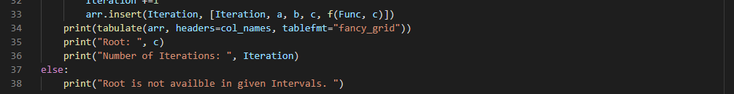

**Output:**

Input : $x- \cos{x} ;[0, 1]$

